Use DAX time intelligence functions in Power BI
In this lab, learn how to use various time intelligence functions to manipulate filter context that specific concerns dates.

Download and Open Day2\Lab3\Lab 3 Starter-Sales Analysis.pbix file

Create a YTD measure
In this task, you’ll create a sales year-to-date (YTD) measure by using time intelligence functions.
- In Power BI Desktop, in Report view, on Page 2, notice the matrix visual that displays various measures with years and months grouped on the rows.
- Add a measure to the Sales table, based on the following expression, and formatted to zero decimal places:
Sales YTD =
TOTALYTD(
SUM(Sales[Sales]),
'Date'[Date],
"6-30"
)
- Add the Sales field and the Sales YTD measure to the matrix visual.
- Notice the accumulation of sales values within the year.
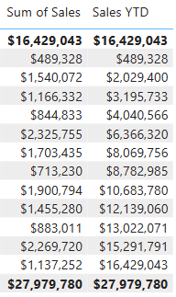

Create a YoY growth measure
- Add another measure to the Sales table, based on the following expression:
Sales YoY Growth =
VAR SalesPriorYear =
CALCULATE(
SUM(Sales[Sales]),
PARALLELPERIOD(
'Date'[Date],
-12,
MONTH
)
)
RETURN
SalesPriorYear

- Add the Sales YoY Growth measure to the matrix visual.
- Notice that the new measure returns BLANK for the first 12 months (because there were no sales recorded before fiscal year 2017).
- Notice that the Sales YoY Growth measure value for 2018 Jul is the sales value for 2017 Jul.
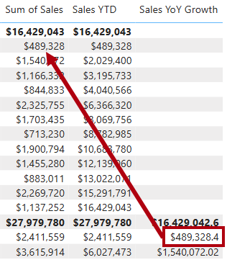
- To complete the measure, overwrite the Sales YoY Growth measure with this formula, formatting it as a percentage with two decimal places:
Sales YoY Growth =
VAR SalesPriorYear =
CALCULATE(
SUM(Sales[Sales]),
PARALLELPERIOD(
'Date'[Date],
-12,
MONTH
)
)
RETURN
DIVIDE(
(SUM(Sales[Sales]) - SalesPriorYear),
SalesPriorYear
)
- In the formula, in the RETURN clause, notice that the variable is referenced twice.
- Verify that the YoY growth for 2018 Jul is 392.83 percent.
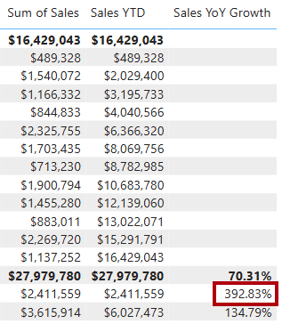

- In Model view, place the two new measures into a display folder named Time intelligence.
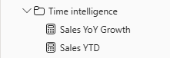
- Save the Power BI Desktop file.

